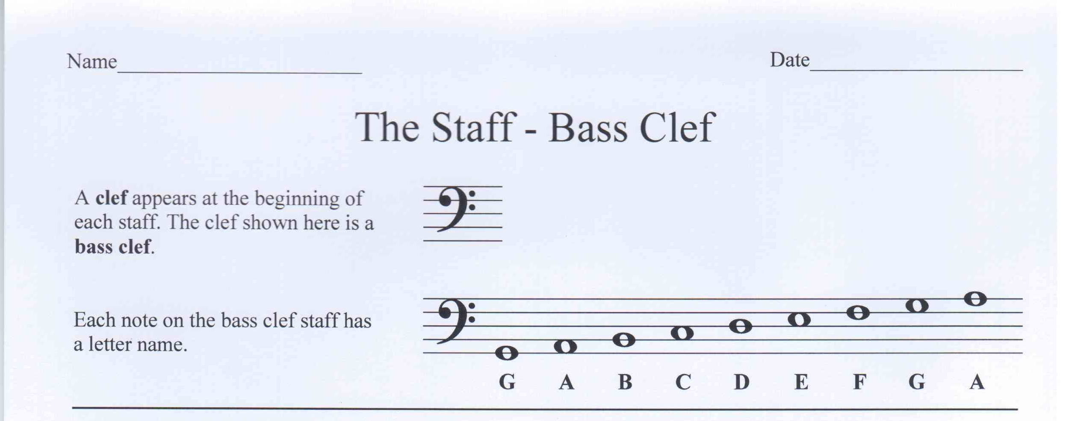

Write in the letter name of each note. Make the text of the lowest note in the row bold.

A
A
A
E
G
C
D
G
B
E

Identify each note and make the text of the highest note in each measure bold. Remember measures are separated by bar lines. The first one is an example.

C
F
G
G
E
F
A
A
G
F
G B

Identify each note and make the text of the lowest note in each measure bold. Remember measures are separated by bar lines. The first one is an example

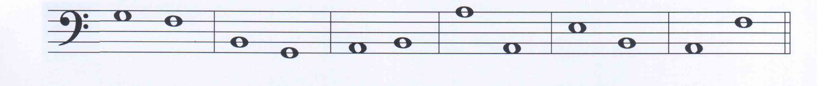
B
G
A
B
A
A
E
B
A
F
G F

